**Que. 1: Write a Python program to convert kilometers to miles?**

**Ans:** We can convert kilometers to miles using the conversion factor: 1 kilometer = 0.621371 miles. Below’s a Python program to perform this conversion:

def km_to_miles(kilometers):

miles = kilometers * 0.621371

return miles

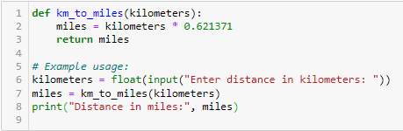

**Example:**

kilometers = float(input("Enter distance in kilometers: "))

miles = km_to_miles(kilometers)

print("Distance in miles:", miles)

**Que. 2:**

**Ans:** As we know we can convert Celsius to Fahrenheit using the formula:

**Fahrenheit=95×Celsius+32Fahrenheit=59​×Celsius+32**

Below’s a Python program to perform this conversion:

def celsius_to_fahrenheit(celsius):

fahrenheit = (celsius * 9/5) + 32

return fahrenheit

**Example:**

celsius = float(input("Enter temperature in Celsius: "))

fahrenheit = celsius_to_fahrenheit(celsius)

print("Temperature in Fahrenheit:", fahrenheit)

**Que. 3: Write a Python program to display calendar?**

**Ans:** We can use the calendar module in Python to display a calendar. Below’s a simple program to display a calendar for a given year and month:

import calendar

def display_calendar(year, month):

cal = calendar.month(year, month)

print("Calendar:")

print(cal)

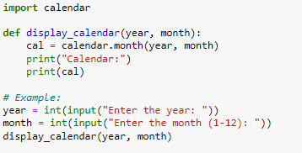

**Example:**

year = int(input("Enter the year: "))

month = int(input("Enter the month (1-12): "))

display_calendar(year, month)

**Que. 4: Write a Python program to solve quadratic equation?**

**Ans:** To solve a quadratic equation of the form 𝑎𝑥2+𝑏𝑥+𝑐=0*ax*2+*bx*+*c*=0, you can use the quadratic formula:

𝑥=−𝑏±𝑏2−4𝑎𝑐2𝑎*x*=2*a*−*b*±*b*2−4*ac*​​

Below’s a Python program to solve a quadratic equation:

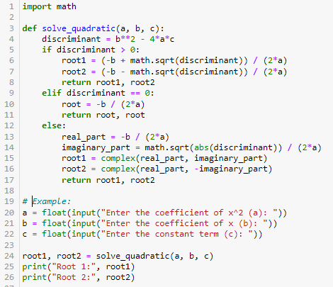

**Que. 5: Write a Python program to swap two variables without temp variable?**

**Ans:**

In above program:

* The swap_without_temp() function takes two variables a and b and swaps their values without using a temporary variable**.**
* Inside the function, the values of a and b are simultaneously assigned to b and a, effectively swapping their values.
* When calling swap_without_temp(x, y), the returned values are assigned back to x and y, effectively swapping their values.
* This results in swapping the values of x and y without using a temporary variable.

**Top of Form**